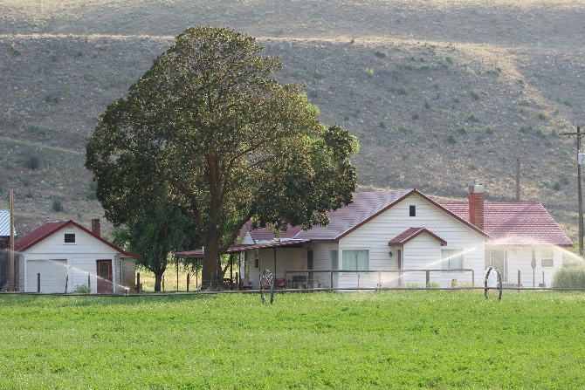
The Guesthouse at Haeberle Ranch

Cellular phones do not work here unless you have wifi calling.
WIFI CONNECT TO THE “HALFWAY HOUSE.” NO PASSWORD.
SMART TV HAS NETFLIX AND WILL ALSO CONNECT TO YOUR ACCOUNTS.
FIRE EXINGUISHERS LOCATED UNDER THE KITCHEN SINK.

House Rules and Expectactations
- Base rates are set at $150 a night for 2 people.
- EXTRA GUESTS cost $20 per person per day. We personally greet every set of guests and clean the house ourselves. There is no chance that you can sneak in extra guests without paying.
- Maximum of 10 guests in the Guesthouse. No exceptions.
- Minimum 2 night bookings.
- Holidays and holiday weekends require a minimum 3 night booking.
- NO PETS!
- NO DRUGS!
- NO FARM HATERS OR COW HATERS. This is a working ranch. If you have a bad attitude about agriculture, don’t come here!!
- NO SMOKING IN THE HOUSE!
- SMOKING OUTSIDE IS RESTRICTED TO THE GRAVEL AREA. BUTTS MUST BE SAFELY DISPOSED.
- No “real” campfires. A propane fire pit is located on the patio for your use. Please do not put garbage in the propane fireplace.
- Please do not park in the lane that goes out back. Tractors need to be able to pass by the living room windows to care for the animals out there.
- No ATV riding on the grounds at the Guesthouse. ATV riding is restricted to designated roads. See maps for ATV riding.
- Air conditioner will FREEZE UP and stop working if turned lower than 72 degrees.
- GARBAGE CAN BE PLACED IN THE LARGE RED DUMPSTER NEAR THE HAYSTACKS.
- PLEASE STRIP THE SHEETS OFF OF EVERY BED THAT WAS SLEPT IN.
- PLACE PILES OF DIRTY SHEETS AND TOWELS NEXT TO THE WASHER AND DRYER.
- PLEASE LOAD THE DISHWASHER AND START IT.
Thanks for coming! We hope you enjoyed your visit!!
GUESTHOUSE MAP
All bedroom windows can be used as emergency exits.
Flashlights are located in the kitchen drawer left of the dishwasher.

EXIT
EXIT
EXIT
BASEMENT
STAIRS
BATHROOM
BATHROOM
KITCHEN
*FIRE EXTINGUISHERS
UNDER SINK
BEDROOM
DINING ROOM & LIVING ROOM
BEDROOM
BEDROOM

